

EC Declaration of Conformity
We hereby declare that the following specified equipment complies with
☑ (MED) the Marine Equipment Directive 2014/90/EU and Implementing Regulation (EU) 2024/1975.
Equipment description: Type: ²
HiNAS Control Standard
{{SERIAL_NUMBER}}
Unique reference: 2
Avikus Co., Ltd.

Manufacturer:
7-12, Jungang-daero 236beon-gil, Dong-gu, Busan, Republic of Korea

Manufacturer Address:

This equipment has been tested to verify compliance with the following Regulations and Testing Standards:
(EU) 2025/1533, MED/4.33 Row 1 of 2

As per:
Type-Examination Certificate no. 3
MEDB0000BWN

(for module B):
DNV AS/0575

Issued by (Notified or Approved Body name/number):

Quality System Certificate no.3 (for module D & E):

Issued by (Notified or Approved Body name/number):

Certificate of Conformity no.3 (for module F & G):
{{MED_NUMBER}}

Issued by (Notified or Approved Body name/number):
DNV AS/0575

The technical documentation for this equipment is retained at the following address:
11F 70, Nonhyeon-ro 85-gil, Gangnam-gu, Seoul, Republic of Korea, 70

Place: ( Busan, Republic of Korea )
Date: {{DATE}}

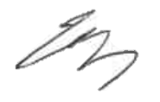
Appointed by the manufacturer as the responsible person for signing this Declaration.
Choi Sangdeok

(name /title)
Address: 7-12, Jungang-daero 236beon-gil, Dong-gu, Busan, Republic of Korea
- Include reference to latest Implementing Regulation valid at the time of production. This may be different from the Implementing regulation stated on the EC certificate
- Acc. to the MED Article 12 “Manufacturers shall ensure that their products bear a type, batch or serial number or other element allowing their identification”. Therefore, please address the type/name/ model/brand name/batch/lot/serial number/ etc. as stated in the MED certificate Module B/F/G.
T5Data from the valid certificate(s)/ modules applied should be listed.
Appendix
1. Product Description
Component | Version
Software | 2.0.3
Ubuntu | 22.04

2. Supply Components List of HiNAS Control
Type | Type Designation | Make | Quantity | S/N
Server | Optiflex XE4 Tower  with damping kit TVK-XE4-TH | Tetradyne | {{QTY_01}} | {{SN_01}}
Client | Optiflex XE4  Tower with damping kit TVK-XE4-TV | Tetradyne | {{QTY_02}} | {{SN_02}}
Monitor | TIMX-W320(32”)  TIMX-UW584(58.4”) | Tetradyne | {{QTY_03}} | {{SN_03}}
Keyboard with trackball | RKTE85B2448-W-MC1 | NSI | {{QTY_04}} | {{SN_04}}
Serial to Ethernet | Nport5450i | Moxa | {{QTY_05}} | {{SN_05}}
Network switch | EDS-G508E | Moxa | {{QTY_06}} | {{SN_06}}
Firewall | FGR-60F | Fortinet | {{QTY_07}} | {{SN_07}}
Selector Switch | MPH731 | Yokogawa | {{QTY_08}} | {{SN_08}}
Selector Switch Dimmer | MKD002 | Yokogawa | {{QTY_09}} | {{SN_09}}
UPS | EATON 9PX 1500iRTM | Eaton | {{QTY_10}} | {{SN_10}}
Camera unit, incl.  EO cameras and IR cameras | HiNAS Navigation | Avikus | {{QTY_11}} | Camera unit :  {{SN_11}}
Junction box, incl.  Single Board Computer |  |  | {{QTY_12}} | Junction box:  {{SN_12}}  Single board computer: {{SN_13}}  EMC -filter:  {{SN_14}}  SMPS:  {{SN_15}}

3. System to be interfaced with HiNAS Control
Type | Type Designation | Make | Quantity | S/N
Heading Control System | PR-9000 (HCS-9000)  (SW version : HCCPU :2.00)  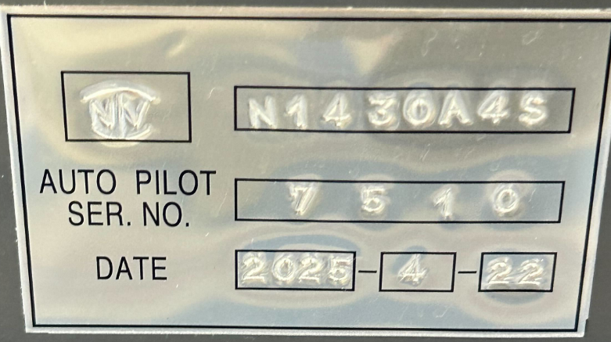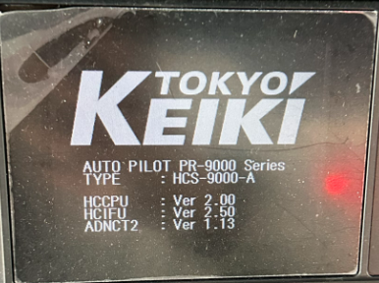 | Tokyo Keiki | 1 | 7610
Remote Control System | AutoChief 600  (SW version : 1.16.131)  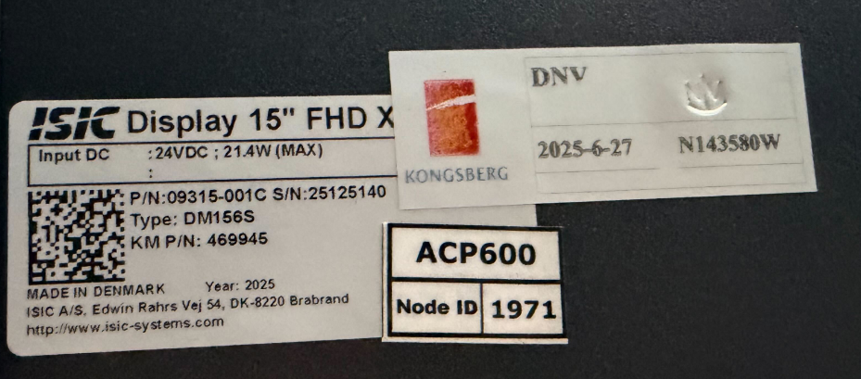  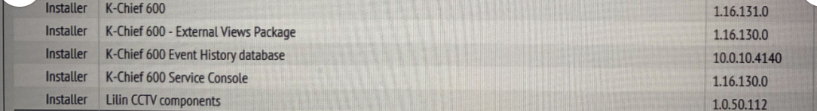 | Kongsberg | 1 | 25125140
ECDIS | NDC-1590A , NDC-1590AE  (SW version : 09.60) | JRC | 2 | LF74951  LF76779
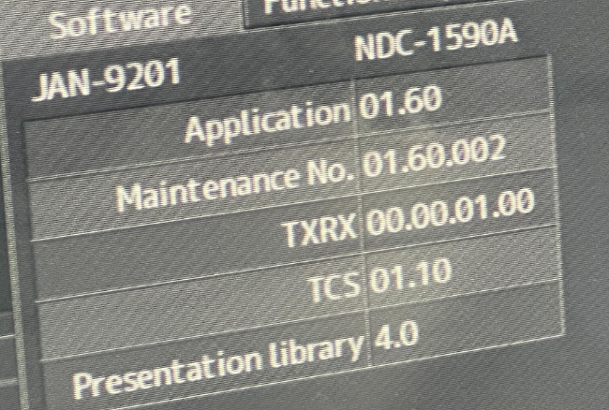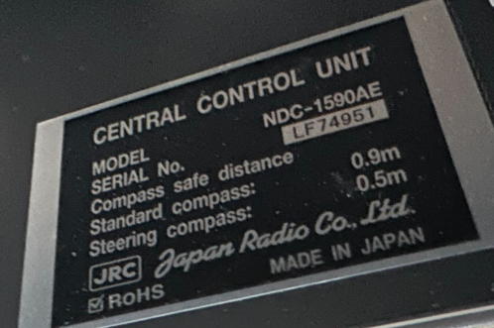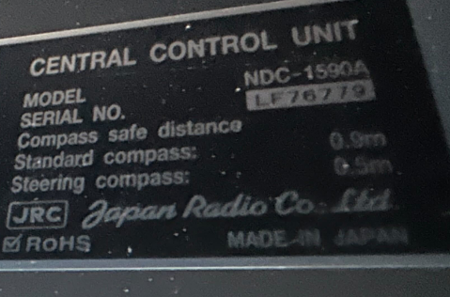
Position Sensor | NWZ-4620 | JRC | 2 | KG56835  KG56831
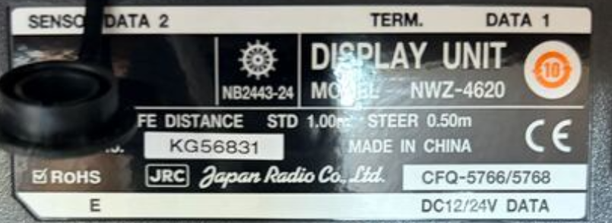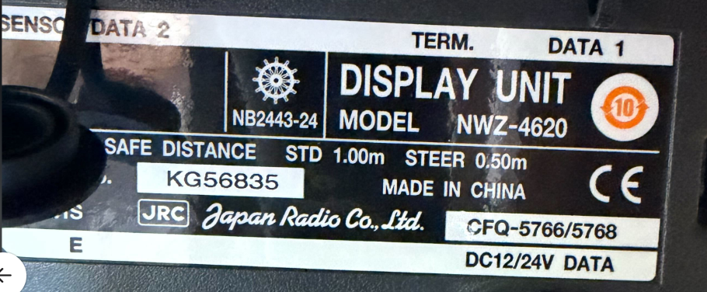
Heading Sensor | TG-8100 | Tokyo Keiki | 1 | 13382
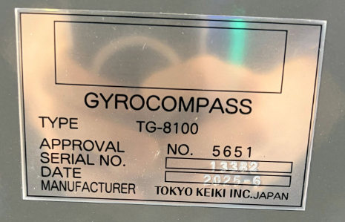
Speed Sensor | NMZ-4640 | JRC | 1 | HE79477
